**C U R R I C U L U M V I T A E**

**Personal Information:**

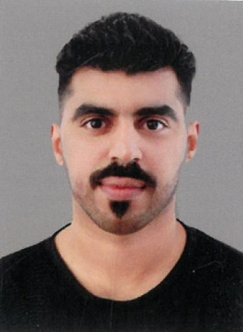**Name** **: Mahmood Jaafar**  **Ali Ali Mohamed**

**Nationality : Bahraini**

**Date of Birth : 19-3-1995**

**CPR No : 950305162**

**Marital Status : Single**

**Address : Villa :711, Road 1110,Block No :1211**

**Telephone : 33607966**

**E-mail : m7moodii95@gmail.com**

**Objective:**

**Seeking a suitable job according to my qualifications, skills and talents, thus to gain more knowledge and experience for a bright career.**

**Education Qualification**

* **Al Jabriya Higher Secodary School**

**Personal Skills:**

* **Training and learning ability and capability.**
* **Excellent communication skills.**
* **Excellent organizational skills.**
* **Team Working .**
* **Driving License.**
* **Order delivery experience certificate 4 years.**

**Work Experience:**

* **Worked in a Nader&Ebrahim S\O Hassan CO. W.L.L – (4 Years)**

**Languages known**.

* **English**
* **Arabic ( Mother tongue )**